**Ruby exercises output screenshots**

**Ex1.rb**

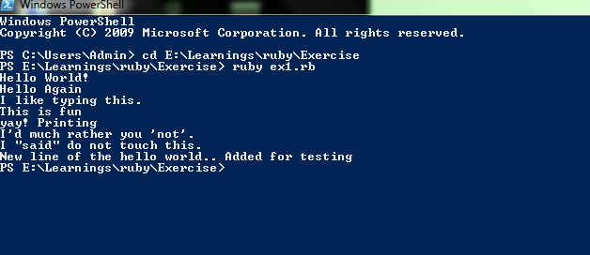

**Ex2.rb**

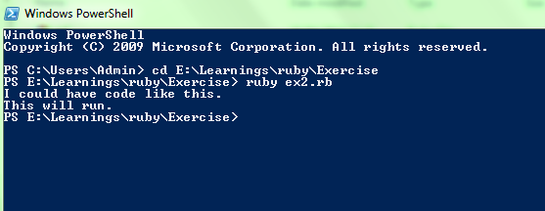

**Ex3.rb**

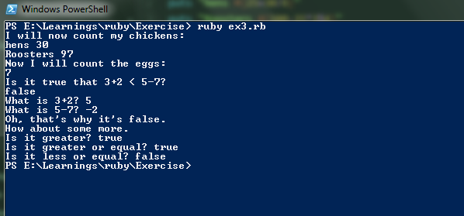

**Ex4.rb**

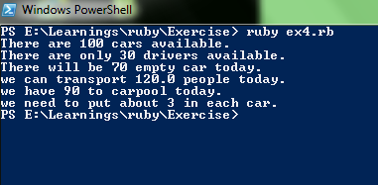

**Ex5.rb**

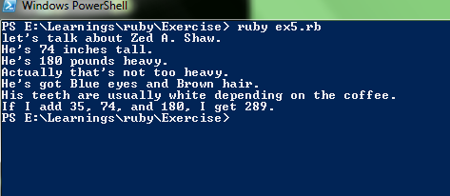

**Ex6.rb**

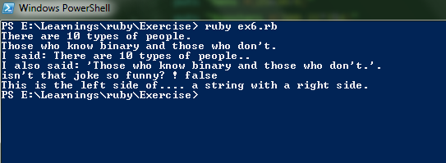

**Ex7.rb**

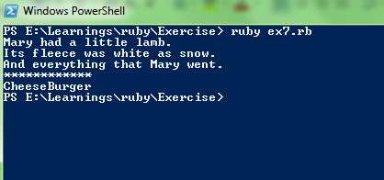

**Ex8.rb**

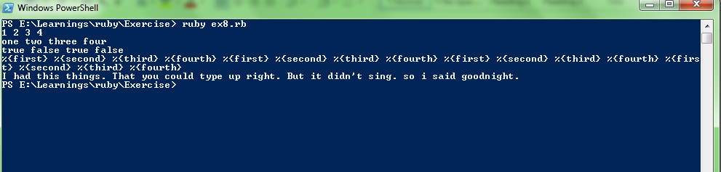

**Ex9.rb**

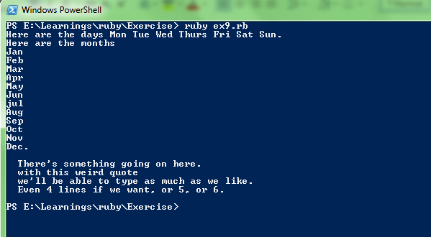

**Ex10.rb**

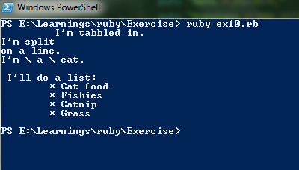

**Ex11.rb**

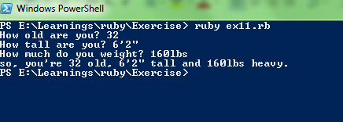

**Ex12.rb**

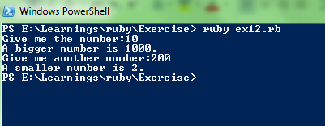

**Ex13.rb**

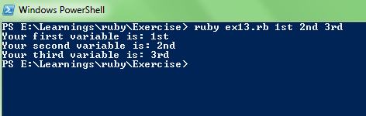

**Ex14.rb**

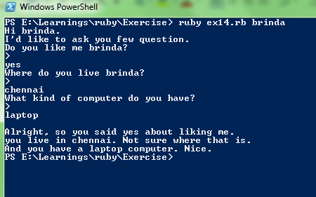

**Ex15.rb**

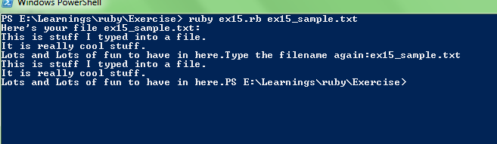

**Ex15_sample.txt**

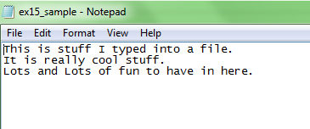

**Ex16.rb**

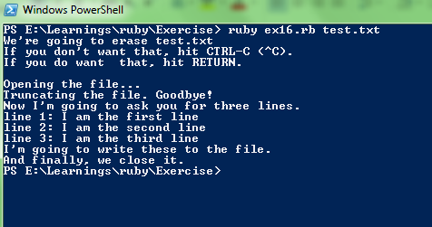

**Test.txt**

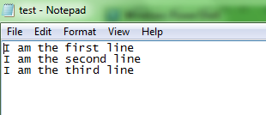

**Ex17.rb**

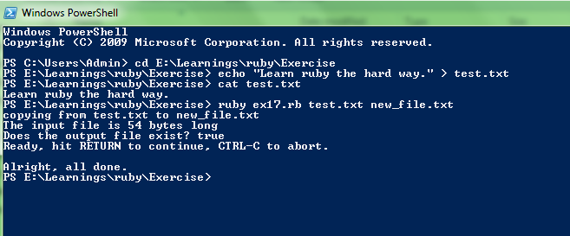

**Test.txt**

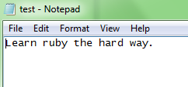

**New_file.txt**

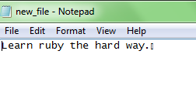

**Text file screen:**

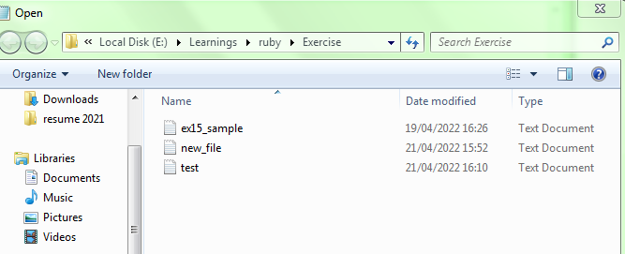

**Ex18.rb**

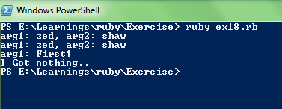

**Ex19.rb**

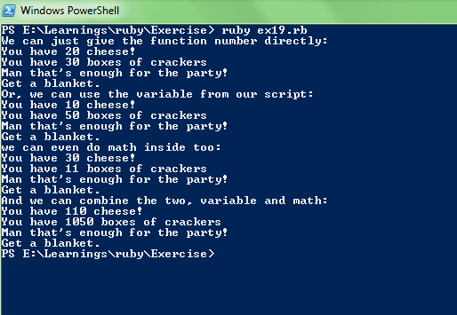

**Ex20.rb**

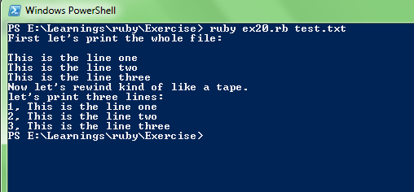

**Ex21.rb**

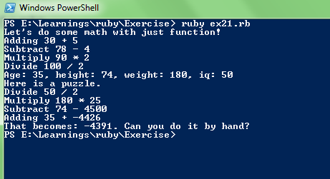

**Ex22.rb**

|  |  |  |
| --- | --- | --- |
| S.No | symbols | Meaning |
| 1. | “ “ | This is used to enclose the strings |
| 2. | #(octothorpe) | This used to include the comment in the code |
| 3. | #{} | This is used for interpolation |
| 4. | %{} | Formatter for string |
| 5. | ‘ ‘ | This is also used to enclose for string |
| 6. | “ “ “ | This is used for multiple line string |
| 7. | () | Used to enter the parameter |
| 8. | \n | New line character |
| 9. | += | Positive increment variable |
| 10. | *args | This is used for Multiple argument |
| 11. | ARGV | Used to enter the argument on the command line |
| 12. | puts | Print the line on the screen |
| 13. | print | Print the line without the newline character |
| 14. | $stdin.gets.chomp | Used to get the input |
| 15. | .to_i | Used to get the interger |
| 16 | Def…..end | Define the function |
| 17. | \t | Hortizontal tab |
| 18. | \r | Carriage return |
| 19. | \f | formfeed |
| 20. | \v | Vertical tab |

**Ex23.rb**

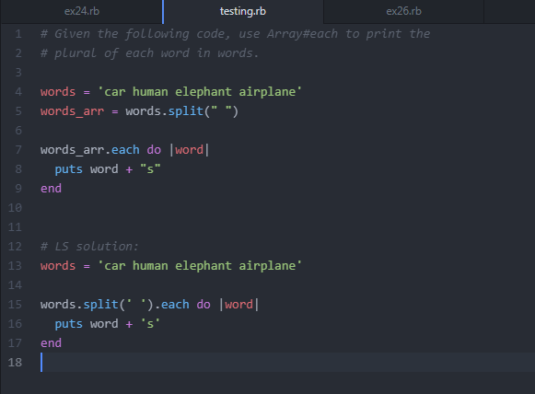

I took this coding from github. This source code is used to split the given string. I learned the new thing in this is words_arr.each do |word|.

**Output for this coding is:**

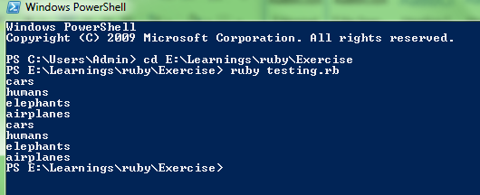

**Ex24.rb**

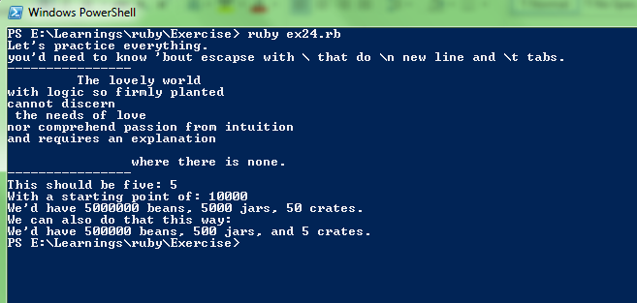

**Ex28.rb**

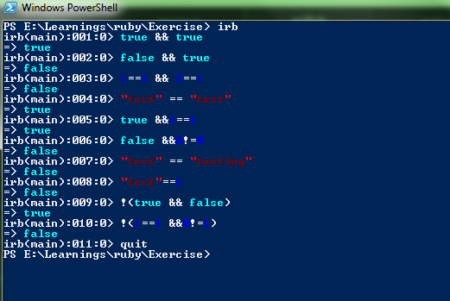

**Ex29.rb**

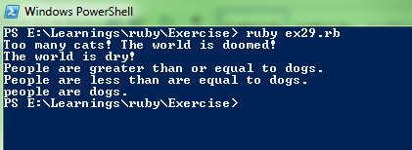

**Ex30.rb**

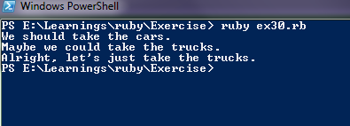

**Ex31.rb**